IT RCSA Audit Documentation
COTS Solution Intent Document – BSI.IT.23.C17
Design Assessment, Walkthrough and Sample of One (DH 3264 – Derivatives NDF) – tested from scratch with the 10/30/2026 evidence
DESIGN RATING | SAMPLE 3264 | CPA RATING | OBSERVATIONS
SATISFACTORY | PASS | SATISFACTORY | OBS-11

Control | BSI.IT.23.C17 – COTS Solution Intent Doc (Heracles ID 50541403) – Key, Manual, In every operation
Statement | As part of developing a new internal system, customizing vendor products or upgrading existing systems, if Book of Work criteria is met, the Solution Intent document must be reviewed and approved by the Architecture Review Board (ARB) prior to entering the development phase of the SDLC process.
Risk | BSI.IT.23.R2 Design Architecture (Inherent Moderate)
Review period | 09/01/2025 – 08/31/2026 – population 2 projects / 4 releases, 100% tested
Test date / tester | 10/30/2026 – IT RCSA
Test script | No C17 script in the IT RCSA 2026 Test Plan "New test scripts" tab – proposed 9-step script (00 Reference) built from the Test Plan format, the 2026 proposed statement and the 2025 test script (Control Articulation Tracker)
Walkthrough | No 2026 walkthrough held; 2025 test performed with Jose Luis Martinez Avial (BSI Development Director). Confirmation to be obtained in the 2026 walkthrough.
Sample of one | DH 3264 – Derivatives NDF – RL1 (EA 12/10/2025, prod 01/28/2026) and RL2 (EA 03/24/2026, prod 05/08/2026)
Evidence folder | C17 Solution Intent/Evidence (BSI.IT.23.C17.01 – C17.14)

1. Design Effectiveness Summary
The control design is effective. For every SDLC project / release ("In every operation") the Project Manager completes the Solution Intent – the Santander "Single Design" template (v1.3) – which records the Book of Work / ARB criteria (> 2 MM, Cross Functional, New Technology, Strategy New Application, Miscellaneous Request, Cloud Deployment, AI or Quantum Computing). Enterprise Architecture reviews the document, approves it and confirms whether the ARB is required; when a criterion is met the Solution Intent is approved by the ARB before development. The approval is uploaded to Delivery Hub as a gate artifact. The control is preventive and appropriate to mitigate unreviewed / flawed architecture (R2). Manual nature is appropriate – the PM self-assesses the criteria and EA / ARB approve.
HERACLES question | Answer | Rationale (2026)
1 Frequency / trigger | Yes | Every SDLC project / release; ARB criteria assessed in the Single Design.
2 Audit trail / evidence | Yes | Single Design with ARB criteria + EA approval e-mails (C17.04 – C17.12).
3 Policy alignment | Yes | 2025 process map step 1.3 (C17.01); US SDLC Standard / EPMO gates. Gap: not in 2026 map (OBS-07).
4 Thresholds | N/A | Not required for Key controls; the ARB criteria (> $2MM, new technology, cloud, AI …) act as the qualitative trigger.
5 Escalation | Full | Missing EA approval blocks the gate; PM / PMO escalate to EA (C17.06, C17.08).
6 Information reliability | Moderately Reliable | Criteria self-assessed by the PM; manual documents (OBS-08).
7 Evidence obtainable | Yes | Delivery Hub documents provided by the PMO.

Design observations: OBS-04 – EA approval / ARB determination is obtained as a Gate 5 artifact after the Gate 4 (PTB) start of Build; if a project met the ARB criteria, ARB approval would not precede development as the control requires – make the determination a PTB prerequisite. OBS-07 – C17 is in the 2025 process map (v1.0 Draft, step 1.3) but not in the 2026 map (v2.0 Draft) although it is an active Key Control. The Test Plan Control Articulation Tracker flags the statement as missing who / when / evidence / escalation – adopt the 2026 proposed statement (Jira ticket, ARB decision recorded).

2. WT Summary
Model walkthrough language (RCSA CDA Job Aid §4.1): On 10/30/2026, IT RCSA performed a Test of One for BSI.IT.23.C17 through inspection of DH 3264 Derivatives NDF (Release 1 and Release 2), selected from the Delivery Hub SDLC Project List for 09/01/2025 – 08/31/2026. The control is triggered by each SDLC project / release and performed in every operation by the Project Manager (Domingo Megia Planet), who prepares the Single Technical Design and requests approval, and by Enterprise Architecture (Jofman Perez, Enterprise Architect VP), who approves it and determines ARB applicability. The tester reviewed the Single Technical Design RL1 (12/08/2025) and RL2 (03/20/2026) – ARB criteria all "No" – and the EA approval e-mails of 12/10/2025 and 03/24/2026, which demonstrate that the Solution Intent was reviewed by the accountable architecture function and that ARB was not required. The evidence is retained in Delivery Hub. When EA approval is pending, the PM escalates before the gate meeting; when ARB criteria are met, the Solution Intent is presented to the ARB (2025 example: Digital Wealth). Additional iteration: DH 3263 Security Lending (EA 12/04/2025, 02/09/2026, 05/12/2026). Based on the Test of One, the control is appropriately designed to mitigate R2, with the timing observation OBS-04.
Competency (Job Aid §4.4): the PMs applied the ARB criteria and obtained EA approval for every release; the Enterprise Architect holds the authority to approve designs and determine ARB applicability. To be re-confirmed with the control owner (Jose Luis Martinez Avial).

3. Sample of One – DH 3264 Derivatives NDF
Workpaper column | Value / conclusion | Evidence reference | Result
Sample ID | 2 (CPA row 54) | Workpaper CPA tab | Pass
Project in scope | T24 NDF module (MEGA 1937) customization with Murex 3 Latam, Medea, 360, DTCC, Asset Control | C17.03; C17.09 | Pass
Solution Intent documented | Single Design "DH 3264 – Derivatives OTC Customer Phase 1" RL1 v0.1 12/08/2025; RL2 v1.1 03/20/2026 | C17.09; C17.11 | Pass
Book of Work / ARB criteria assessed | All "No" (> 2 MM, Cross Functional, New Technology, Strategy New App, Misc., Cloud – SaaS affiliate, AI); Alexandria Local | C17.09; C17.11 | Pass
ARB approval prior to development | Not required – criteria not met; RL2 "no applicability to ARB" confirmed by EA | C17.12 | N/A
EA approval / determination documented | RL1 "Approved!" 12/10/2025; RL2 "Approved" 03/24/2026 – Jofman Perez | C17.10; C17.12 | Pass
Timing vs Build / production | After PTB (11/04/2025; 03/10/2026) – OBS-04; before production (01/28/2026; 05/08/2026) | C17.14; C25.08; C25.11 | Pass – OBS-04

Conclusion: the Solution Intent for both NDF releases was documented with the ARB criteria assessment and approved by Enterprise Architecture before production; ARB was not required. The sample passes. No exceptions across the 2 projects / 4 releases.

NewTest Script coverage (workpaper tab "New Test Script")
Step | Test script step | Sample of one – answer | Result
1 | Obtain Evidence | Single Technical Designs and EA sign-off e-mails | Completed
2 | Completeness & Accuracy | Traced to release tickets; independent list not provided (OBS-11) | Pass – OBS-11
3 | Population & Scope | Customization – ARB criteria not met | Completed
4 | Control Execution | Criteria assessed; EA approved RL1 / RL2 | Pass
5 | Control Results | Approved by Enterprise Architect, stored in Delivery Hub | Pass
6 | Exception Handling | None | Pass
7 | Escalation & Remediation | N/A | N/A
8 | Risk Mitigation | Architecture reviewed before production | Pass
9 | Testing Coverage | Documented in workpaper (2 projects / 4 releases) | Completed

Evidence references (BSI.IT.23.C17 folder)
Ref | Evidence | What it shows
C17.01 / C17.02 | 2025 and 2026 SDLC process maps | C17 at step 1.3 in 2025; not listed in 2026 (OBS-07)
C17.03 | SDLC Project List (population) | 2 projects SDLC = Yes
C17.04 / C17.07 | SL Single Design (Feb / May 2026) | ARB criteria all No; embedded EA e-mails
C17.05 / .06 / .08 | SL EA e-mails (extracted) | Approved 12/04/2025; no impact 02/09/2026; no ARB 05/12/2026
C17.09 / C17.11 | NDF Single Technical Design RL1 / RL2 | ARB criteria all No; version history
C17.10 / C17.12 | NDF EA sign-off e-mails | Approved 12/10/2025; 03/24/2026
C17.13 / C17.14 | Delivery Hub gate dispositions | PTB dates for timing (OBS-04)

Appendix A – 3264 Evidence
Exhibit A1: Single Technical Design RL1 – 1.1 Introduction & Goals – ARB Criteria (BSI.IT.23.C17.09, slide 5)
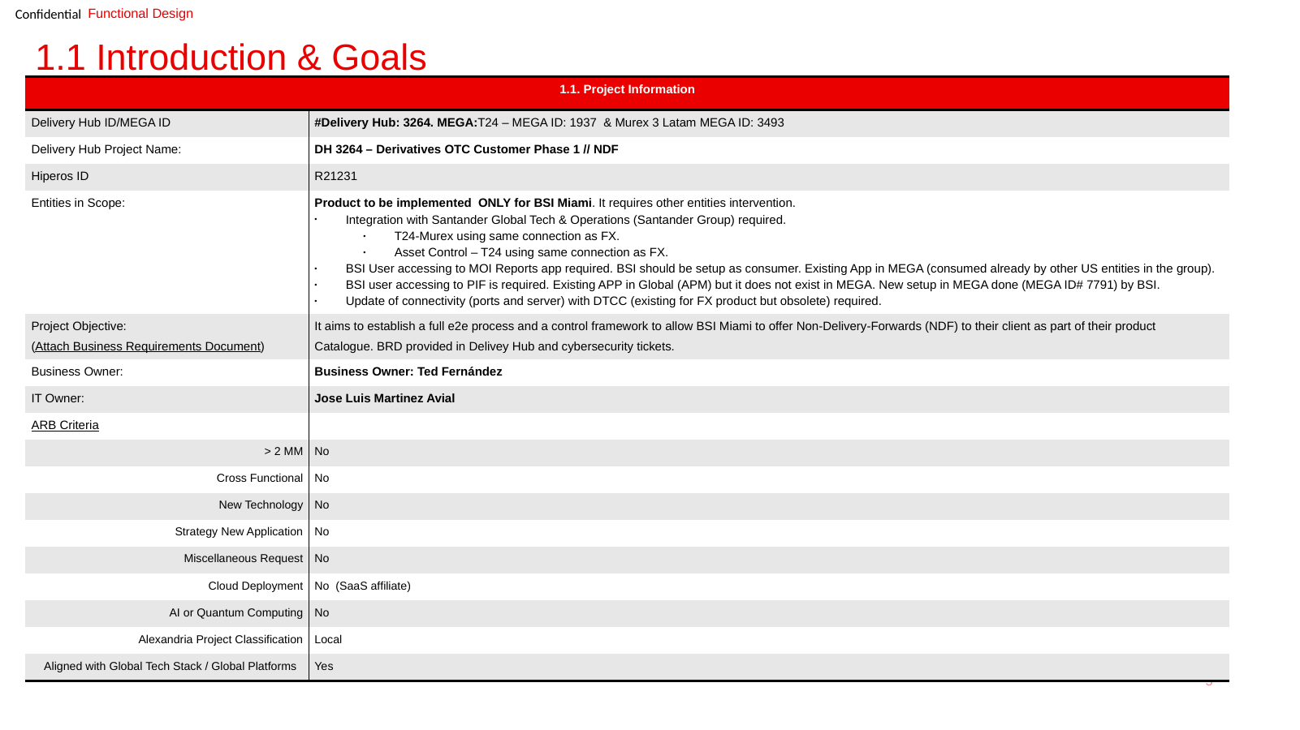
Source: BSI.IT.23.C17.09 (rendered). All ARB criteria "No" – ARB not required.
Exhibit A2: Single Technical Design RL2 – Version Control (BSI.IT.23.C17.11, slide 2)
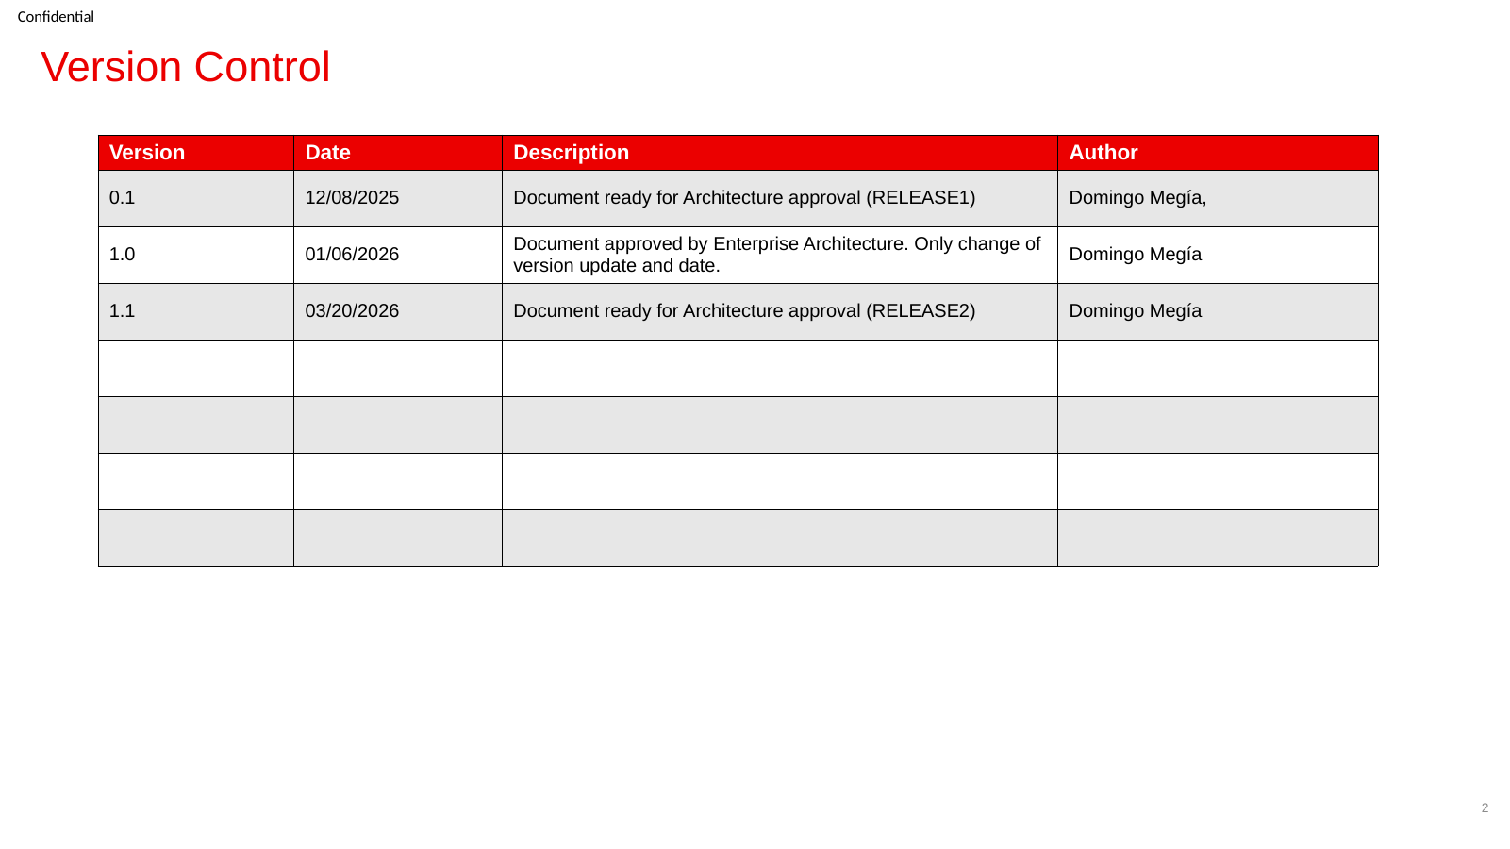
Source: BSI.IT.23.C17.11 (rendered). v1.0 01/06/2026 "Document approved by Enterprise Architecture"; v1.1 03/20/2026 ready for RL2 approval.
Exhibit A3: Enterprise Architecture sign-off e-mails (BSI.IT.23.C17.10, C17.12)
Field | RL1 (C17.10) | RL2 (C17.12)
From → To | Jofman Perez (Enterprise Architect, VP) → Domingo Megia Planet; cc Ted Fernandez, Marcus Medeiros, Javier Nuño | Same; cc IT Governance
Sent | 12/10/2025 12:55 PM ET | 03/24/2026 8:17 AM ET
Request | Approve RL1 Data Flow Guide_final and Single_Technical Design_final – Gate 5 artifacts; Gate 5 meeting 12/15/2025 | Approve RL2 Data Flow Guide (unchanged) and Single_Technical Design (slide 7 note); EA had confirmed RL2 has no applicability to ARB; ISAR / AST N/A; Gate 5 04/06/2026
Response | "Approved!" | "Approved"

Exhibit A4: Additional iteration – DH 3263 Security Lending Single Design, ARB Criteria (BSI.IT.23.C17.04, slide 5)
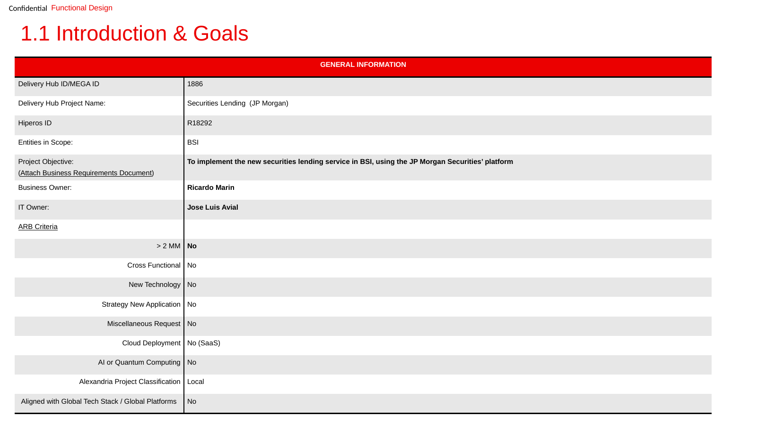
Source: BSI.IT.23.C17.04 (rendered). ARB criteria all "No"; header shows Delivery Hub ID 1886 / "Securities Lending (JP Morgan)" (OBS-08).
Referenced workbook: C17 WP 2026.xlsm – tab "Control Performance Assessment", row 54; tab "New Test Script".

